Quick Connector
--Safety, reliability, long service life, these are guaranteed by careful and
unique design, advanced process, reasonable material and strict quality control.
--Small volume, compact structure, user-friendliness.

B0901/B0902 100Mpa
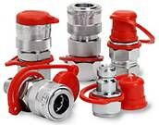
Technical parameters
Material: Hardened steel galvanized
The maximum working pressure: 100Mpa
The minimum broken pressure: 260Mpa
Effective size: 2.5mm
The temperature: -30℃—+100℃
The flow rate under pressure 0.4 Mpa：6.01/min
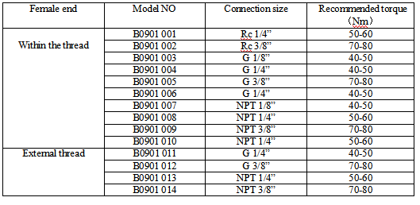
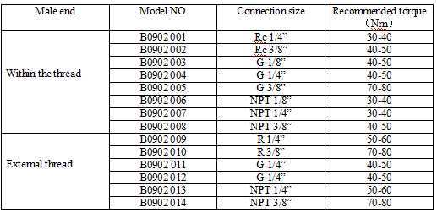

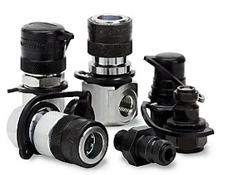
B0903/B0904 150Mpa
Technical Parameters
Material: Hardened steel galvanized
The maximum working pressure: 150Mpa
The minimum burst pressure: 300Mpa
Effective size: 2.5mm
The temperature: -30℃—+100℃
The flow rate under pressure 0.4 Mpa：5.3 l/min
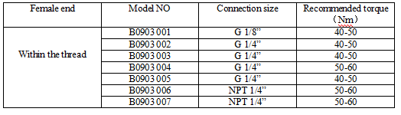
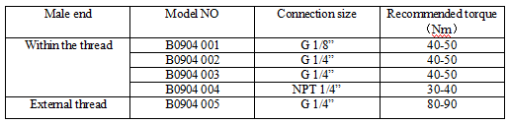

B0905Series High Pressure Hydraulic Hoses
--Tube: oil resistan synthetic rubber.
--Cover: oil, abrasion and weather aging resistant synthetic rubber.
--Temp. Range -40℃~+93℃
--Max.change in length : -4%~+2% (under W.P.)
--Reinforcement: Two layers of steel wire braids.
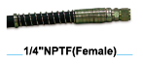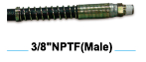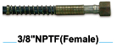
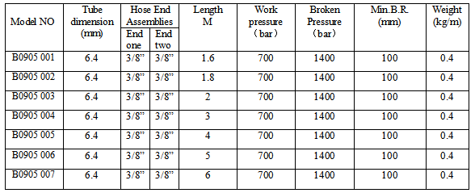

B0908 Series Diverter Valve
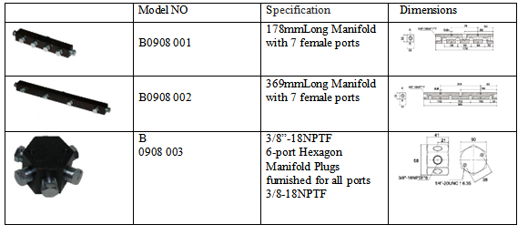

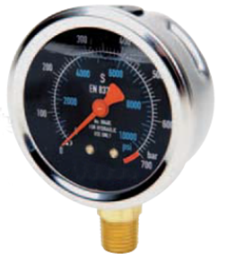
B0909 Series Pressure Gauge
--Pressure gauge is very easy to read, pointer indicating clearly
--High pressure steel spring tube has a very high service life
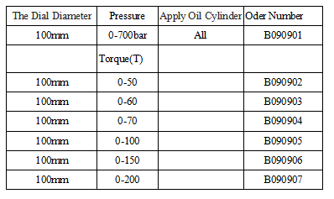

B0907 Series Table Block
--Easy mounting of pressure gauge into hydraulic system.
--Male end screw into pump or cylinder port, female end accepts hose or
coupler, third port is for gauge connection.
